
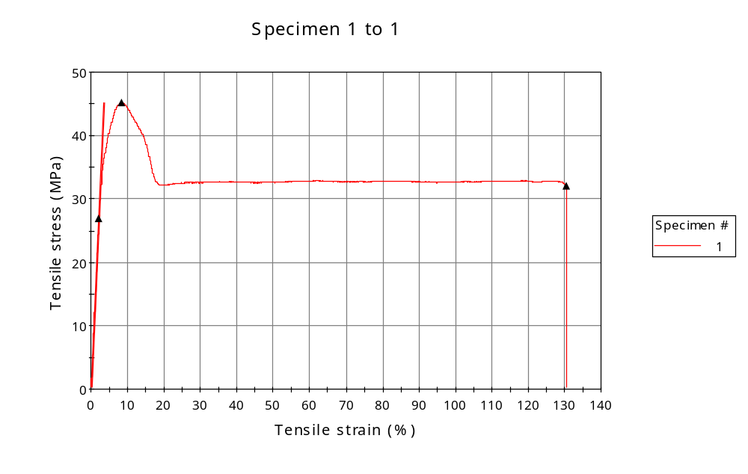
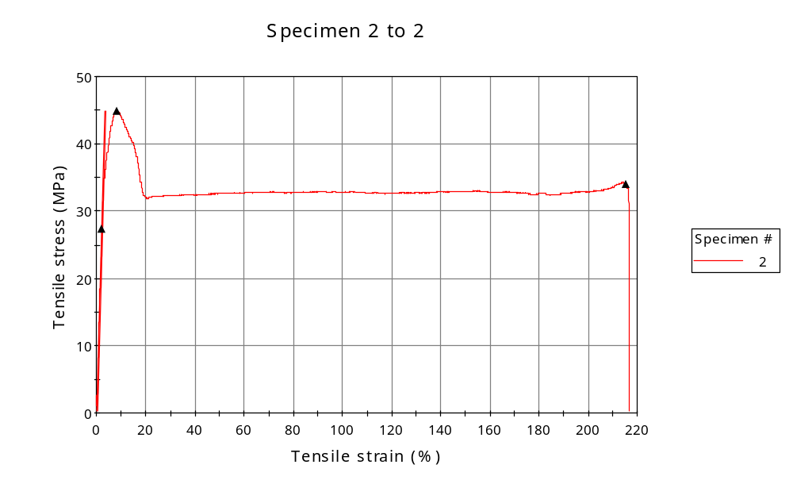
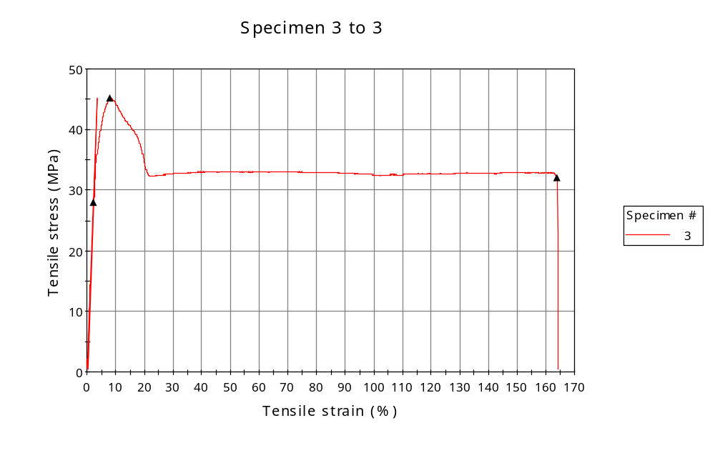
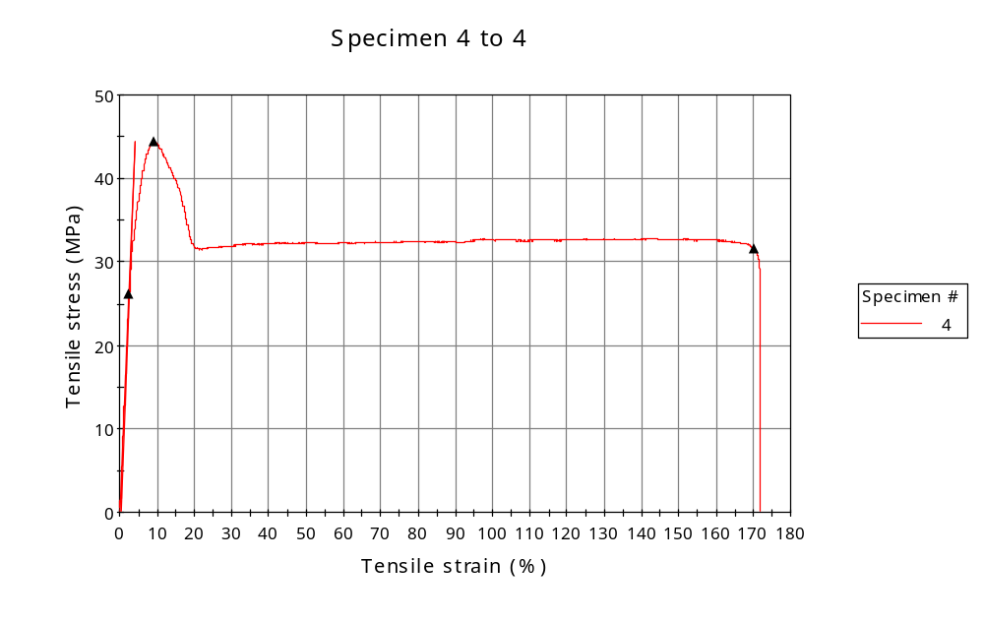
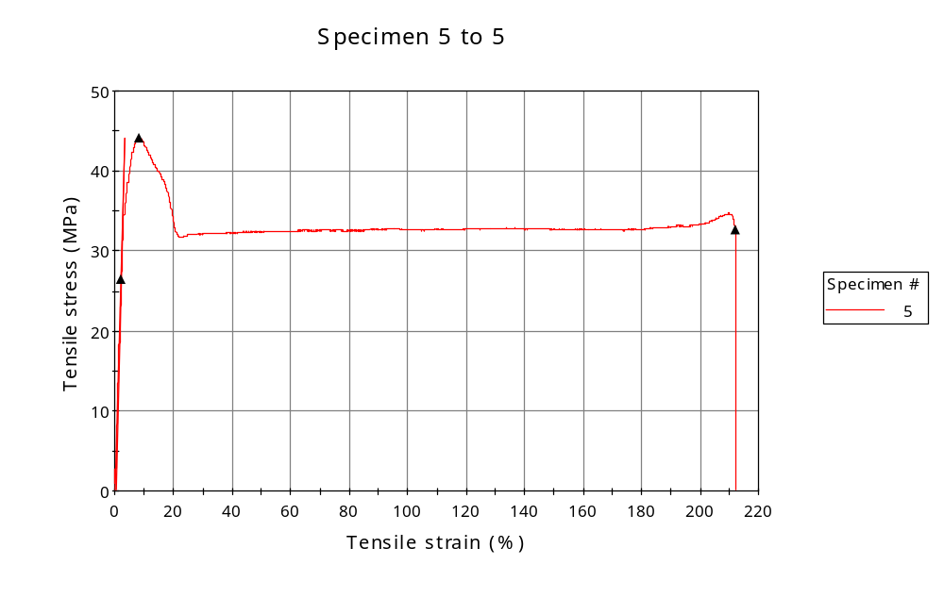
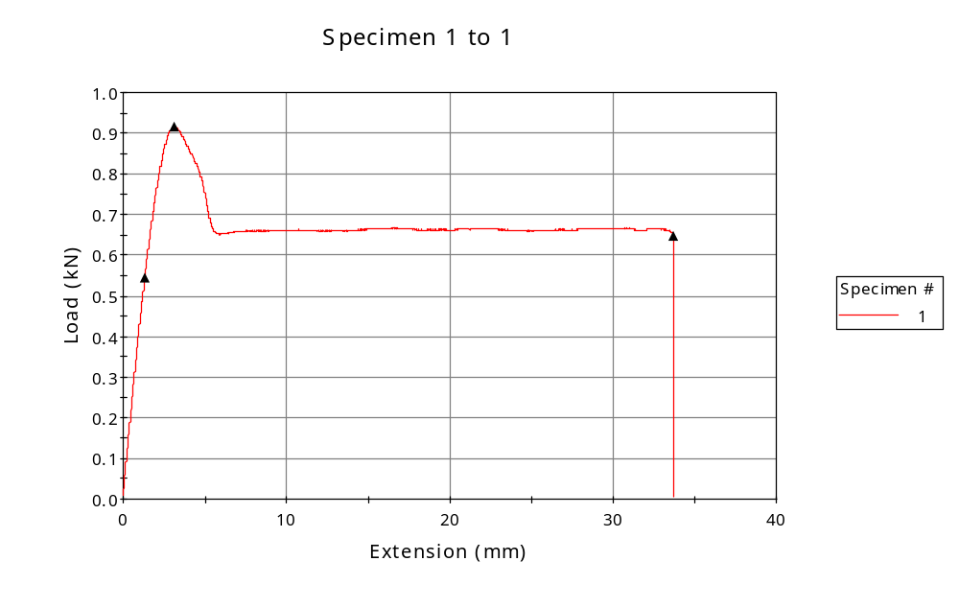
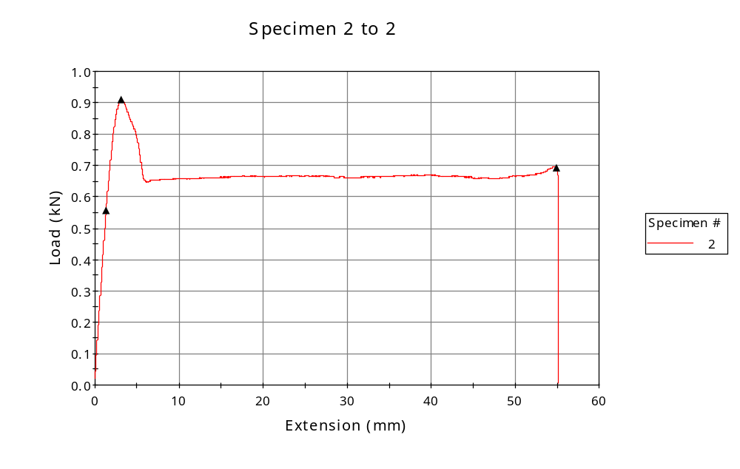
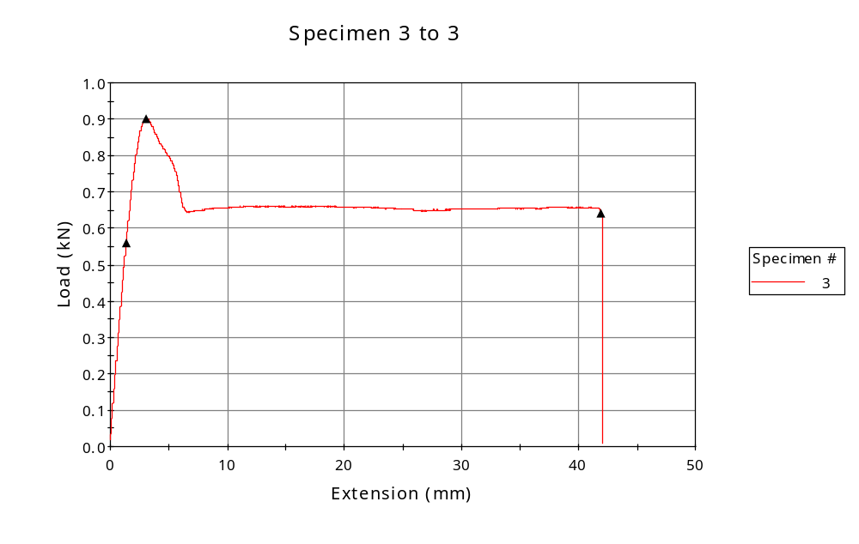
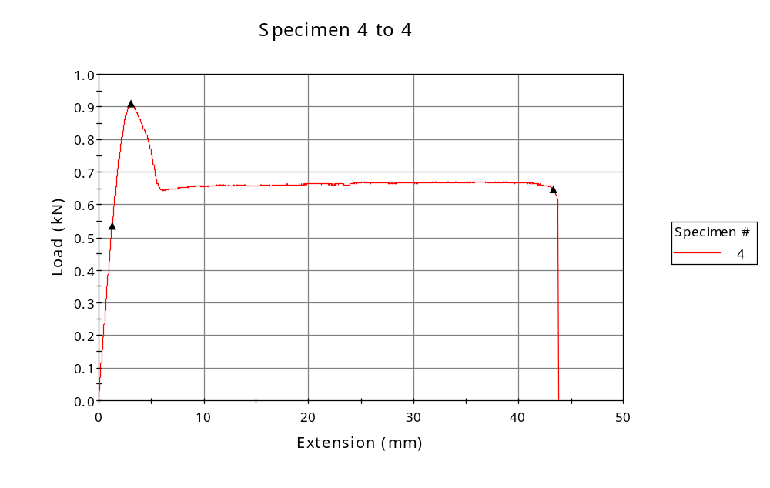
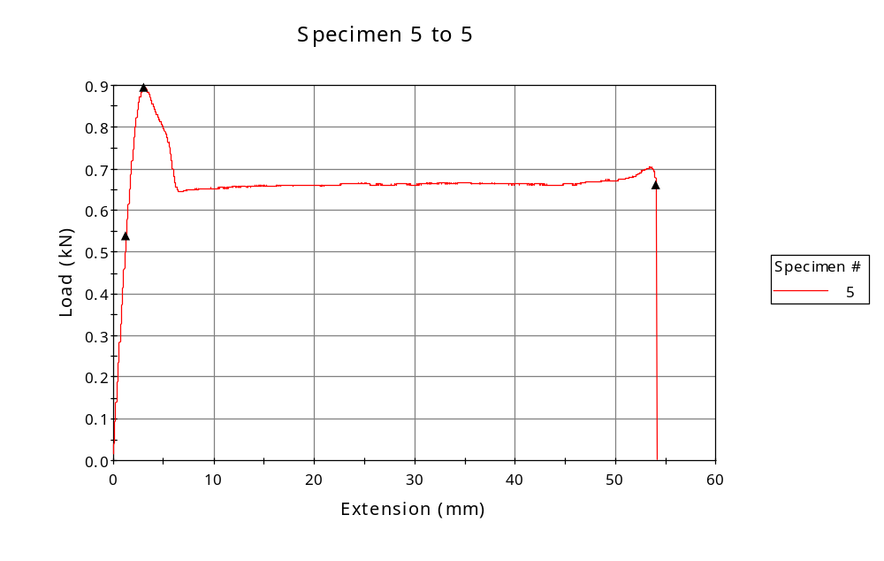

 | CP ID | Length  (mm) | Width  (mm) | Thickness  (mm) | Modulus (Automatic Young's)  (MPa)
1 | CP-FDM_YZ5_01 | 25.00 | 6.16 | 3.29 | 1340
2 | CP-FDM_YZ5_02 | 25.00 | 6.13 | 3.31 | 1335
3 | CP-FDM_YZ5_03 | 25.00 | 6.11 | 3.27 | 1325
4 | CP-FDM_YZ5_04 | 25.00 | 6.11 | 3.35 | 1141
5 | CP-FDM_YZ5_05 | 25.00 | 6.11 | 3.32 | 1333
Maximum |  | 25.00 | 6.16 | 3.35 | 1340
Minimum |  | 25.00 | 6.11 | 3.27 | 1141

 | Load at Fy ( 0.2 %) - LE  (kN) | Tensao em Fy ( 0.2 %) - LE  (MPa) | Deformacao em Fy ( 0.2 %) - LE  (%) | Forca Max  (kN) | Tensao na Forca Max - LR  (MPa)
1 | 0.545 | 27 | 2.202 | 0.916 | 45
2 | 0.556 | 27 | 2.249 | 0.910 | 45
3 | 0.559 | 28 | 2.308 | 0.901 | 45
4 | 0.535 | 26 | 2.517 | 0.908 | 44
5 | 0.538 | 27 | 2.181 | 0.896 | 44
Maximum | 0.559 | 28 | 2.517 | 0.916 | 45
Minimum | 0.535 | 26 | 2.181 | 0.896 | 44

 | Deformacao na Forca Max - LR  (%) | Forca na Forca na Quebra - LQ  (kN) | Deformacao na Forca na Quebra - LQ  (%) | Final length  (mm) | Final width  (mm)
1 | 8.451 | 0.648 | 130.450 | 119.00 | 6.82
2 | 8.313 | 0.691 | 215.414 | 119.00 | 6.82
3 | 8.108 | 0.639 | 163.809 | 119.00 | 6.82
4 | 9.180 | 0.647 | 170.047 | 119.00 | 6.82
5 | 8.267 | 0.661 | 212.067 | 119.00 | 6.82
Maximum | 9.180 | 0.691 | 215.414 | 119.00 | 6.82
Minimum | 8.108 | 0.639 | 130.450 | 119.00 | 6.82

 | Alongamento
1 | 3.76
2 | 3.76
3 | 3.76
4 | 3.76
5 | 3.76
Maximum | 3.76
Minimum | 3.76

